Over the Horizon

* A spaceship FPS shooting game

## Competitive Analysis:

**Similar programs:**

* World of Warships
* War Thunder
* EVE
* Starwar battlefront
* **World of Warships:**
* Ships travelling on the sea. All the shells travels in parabolic path players need to estimate the lead. Ships travelling in 2d world make it much easier to estimate the lead.
* In Wows ships engine, rudder and cannons might be incapacitated which make the game more realistic and interesting. This can be added.
* WOWS give player some consumables to use such as damage control, scout, repair, which repair incapacitated ships parts, increase shooting range and add player HPs.
* WOWs have ship on fire and ship flooding damages. This can be added such as fueling leaking, oxygen leaking or structure burning damages.
* Ships have AA guns, which are used to shoot down carrier airplane squads. This can be added to ships to defense against missile damages. The missile will explode with some distance to the ship and thus do less damage.
* 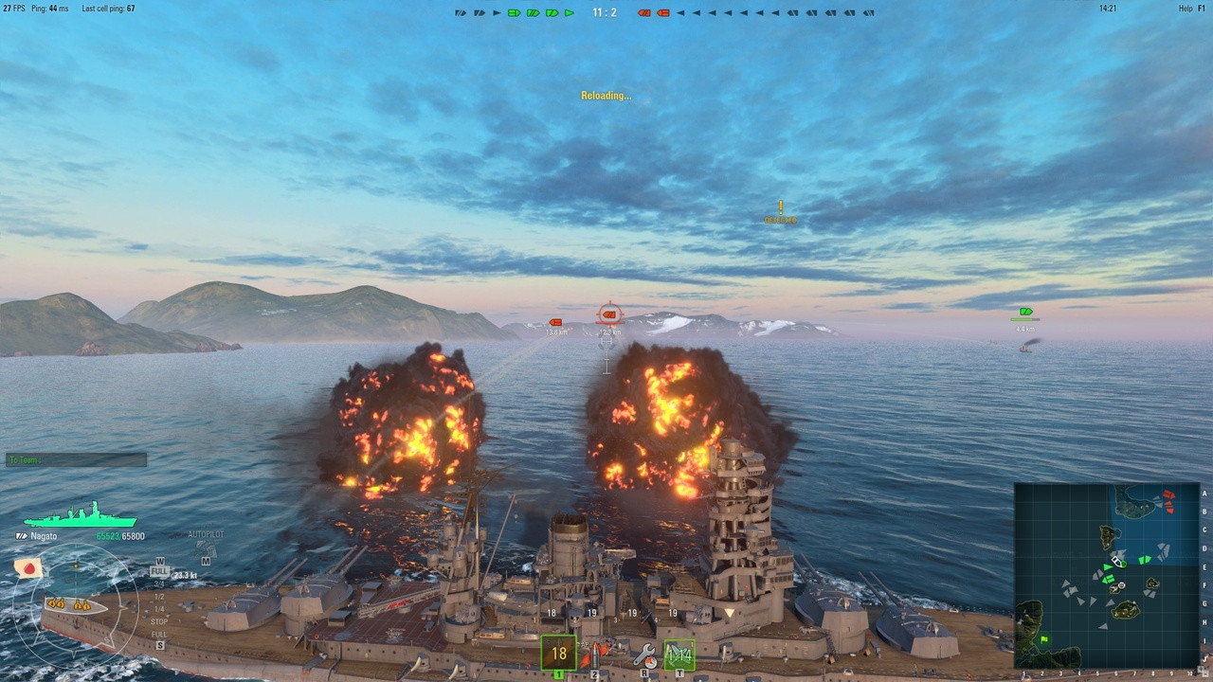 Ship status display will help player understand movements

http://i.imgur.com/JxN7Uxt.jpg

* **War Thunder:**
* This is a 3d flying fps game. It’s physics is awesome. Having said that, all it’s shells travels in parabolic arcs so it’s really hard to aim. The game thus provide a rough estimate. A circle is given for player to shoot into so that the shells are more likely to hit. This feature can be added.
* War Thunder use modulus damage model where parts of airplanes might be destroyed and influence the maneuverability of the airplanes. This can be added in to the game such as the Radar of the ship is broke s the map is disabled. Player have to find enemy with eyes.
* Electronic system failed player can only fire shells with no guiding, etc.
* 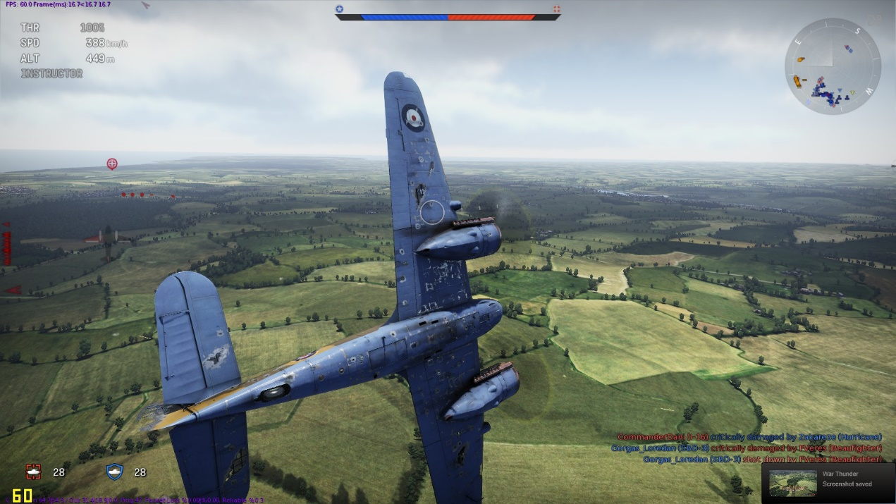Vehicle statistics might also make the game more interesting to play.
* http://s3.amazonaws.com/gameplay-production/virtual_controllers/meta_images/000/006/972/original/War-Thunder-4.jpg?1408982372
* **EVE**
* Eve provided me with the idea of have three layers of HP: shield, Armor and structure and they each have different features.
* Player can control turrets separately and are able to modify them, this might make the game more competitive but will effective make the game more complex.
* 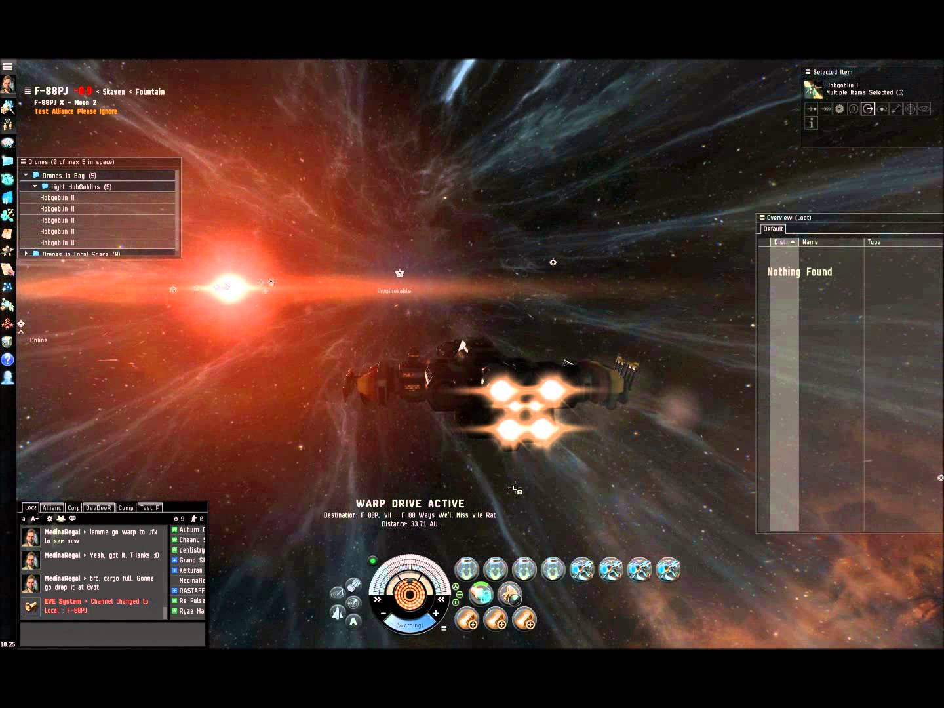 EVE is a 3d space game, the way it handles the camera is fairly complicated but very proper and comfortable. When the player rotate the ship along Z axis, the camera will stay in the original level and let the ship turn, and then the camera adjust and let the ship on the camera horizon. Players can easily drag the camera and change the direction of view along x y z axis.
* https://i.ytimg.com/vi/pDaUv5SvJHE/maxresdefault.jpg

* **Starwar battlefront**
* 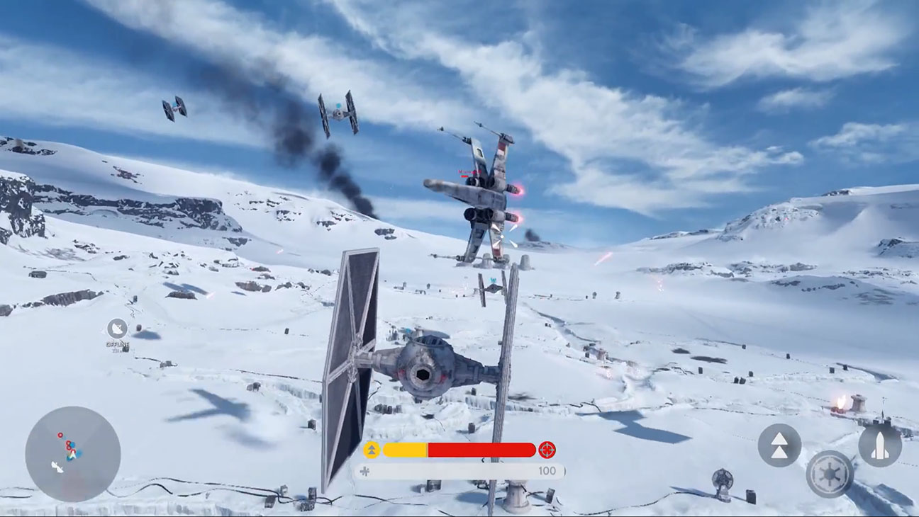 This is a recently published FPS game with air combat mode. The game pace is very fast and the thing I like about this game is that it gave players lots of power ups so the game become more interesting. Also it implement auto aiming. Main cannons will auto adjust to best angle when target is within the aiming range. This is proper for airplane cannons but not so much for battleship shells.

**http://cdn5.thr.com/sites/default/files/2015/06/star_wars_battlefront_gameplay_e3.jpg**